**What is St. Theresa’s Parish St. Theresa’s Parish**

**Safeguarding? Brief Guide Representative Safeguarding Team Safeguarding Prayer**

**NCSC**

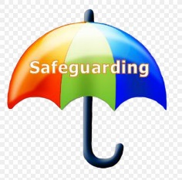

**NCSC St. Theresa’s Role Task 7 Standards Covid-19**

**Policy Policy Descriptions & Audit**



**Scams/Fraud On-Line Mental Domestic Counselling**

**& Cyber Crime Safety Health Abuse Support**



**Covid-19 Counselling Domestic On-Line Mental**

**Support Safety Health**



**Covid-19 Counselling Domestic On-Line Mental**

**Support Safety Health**



